Practical - 5
Practical Title: Registration Form with Frontend Validation and User-Friendly Error Handling
Problem Definition: Create a student registration form with HTML5 input types and JavaScript validation for name, email, mobile number, password, confirm password, course, year, gender, and terms acceptance. Use Regular Expression for validations.

Theory

Are correct input types and attributes used?
Answer: Use appropriate types like email, password, and text, with attributes such as required and minlength.

Are validation errors displayed near the relevant fields?
Answer: Display clear error messages close to the related input field.

Is password strength checked?
Answer: Check password length and strength requirements.

Is the form accessible using keyboard and screen-reader-friendly labels?
Answer: Use proper labels and ensure all form fields can be accessed using the keyboard and screen readers.

Implementation :

- Use correct input types and attributes such as email, password, required, and minlength for form validation.
- Display validation errors near the relevant fields and check password strength.
- Use proper <label> elements and keyboard-friendly controls to make the form accessible to screen readers.

Evidence of Work (Screenshots)
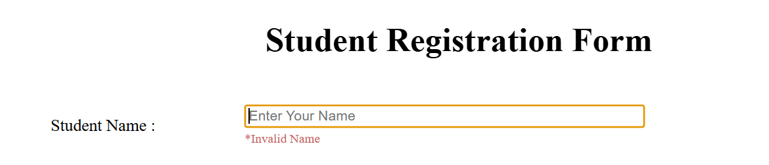
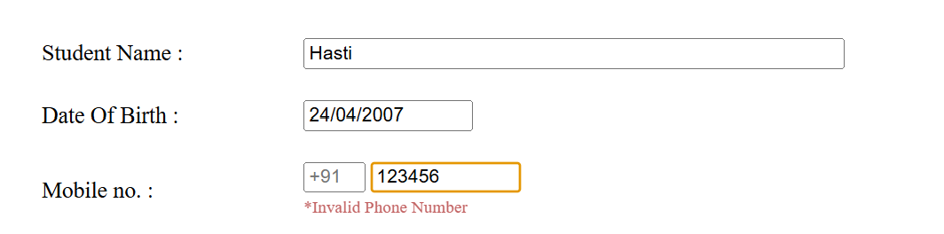
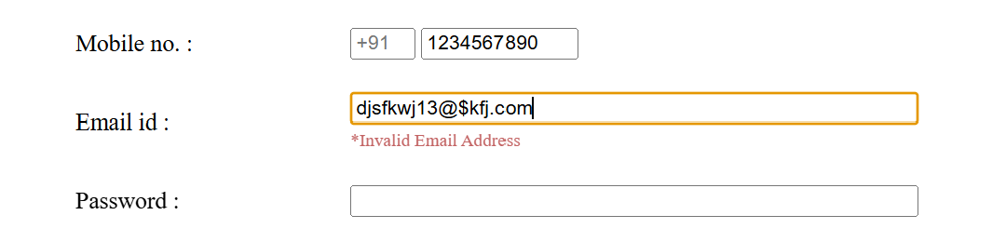
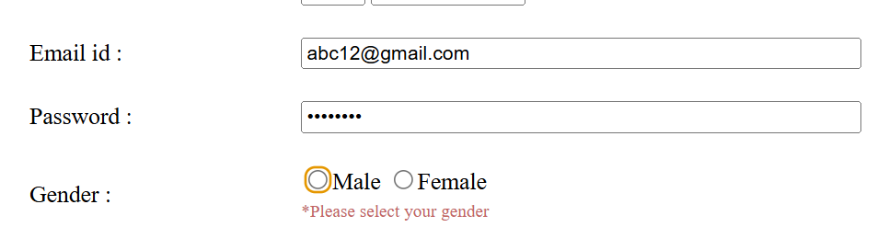
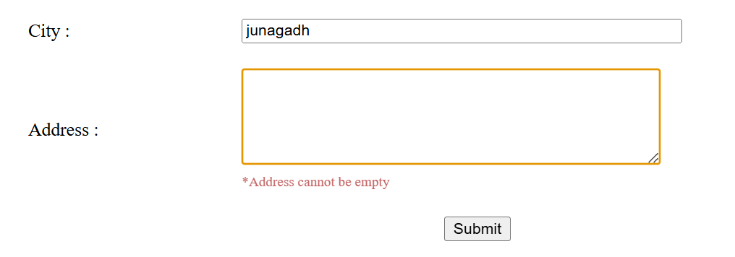
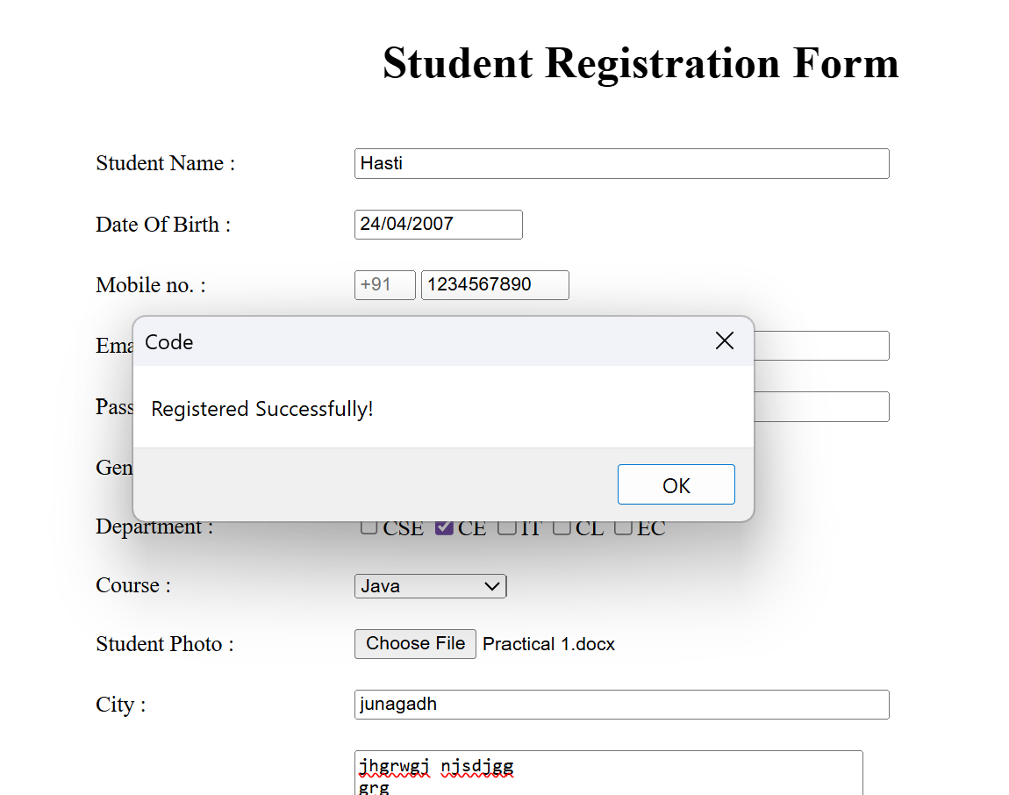

GitHubRepositoryLink:
https://github.com/kansagarahasti24/WDF

Challenges Faced:
• Choosing the correct input types and implementing proper validation for each field.
• Displaying error messages near the correct fields and checking password strength.
• Making the form keyboard accessible and adding screen-reader-friendly labels.

Learning Outcomes:
• Learned how to use proper input types and form validation techniques.
- Learned how to display field-specific errors and check password strength.
- Understood the importance of accessibility using labels, keyboard navigation, and screen readers.

Faculty Remarks: (Keep this blank for faculty)

